PUSHPAK GRAND CHALLENGE 2026
TECHFEST 2026–27 • IIT BOMBAY
GRAND CHALLENGE 3
SECURITY OF DRONES

OBJECTIVE 2
DRONE INTRUSION DETECTION SYSTEM (DRONE IDS)

Team Name | AERO EXPERTS
Institute / College | MUKESH PATEL SCHOOL OF TECHNOLOGY MANAGEMENT AND ENGINEERING
Team Members | GYAAN JHUNJHUNWALA, PRANAY DHARHAS VARANASI, HIRANYA, MANAV VIPANI, TURVIKSH MURUDKAR
Faculty Mentor | NILESH BALKI
Submission Stage | Stage 1 – Preliminary Design Verification

Technical Report • September 2026

Document Control
Document | Version | Date | Status
Drone IDS Technical Report | 2.0 | September 2026 | Stage 1 Draft / Updated after latest prototype benchmark
Source basis: Techfest 2026–27 / PUSHPAK Grand Challenge 2026 rulebook supplied for this project. Competition-specific requirements in this report are derived from the rulebook, especially Objective 2, pages 9–13.

Executive Summary
The PUSHPAK Grand Challenge 2026, Grand Challenge 3 – Security of Drones, defines a Drone Intrusion Detection System (Drone IDS) challenge focused on real-time cyber-threat detection and monitoring for UAV platforms. The required system is expected to monitor security-relevant UAV data, detect representative cyberattacks with high accuracy and low latency, operate with limited computational and power overhead, and support event logging, attack classification, secure alerting, and comprehensive reporting.
This project proposes a modular Drone IDS architecture centered on continuous telemetry and security-event monitoring. The Stage 1 proof-of-concept is designed around simulated UAV telemetry and software-based attack scenarios so that the detection logic can be verified before hardware deployment. The prototype workflow covers data generation/acquisition, feature extraction, attack detection, event classification, secure logging, benchmarking, and structured reporting.
The design specifically addresses the attack classes named by the competition: GPS spoofing, MAVLink communication anomalies, command injection, telemetry manipulation, denial-of-service attacks, and firmware-integrity violations. The architecture is intentionally modular so that the simulation layer can later be replaced or connected to a real UAV/flight-controller data source.

1. Problem Definition
Grand Challenge 3 is titled “Security of Drones” and contains two objectives. Objective 2 is the Drone Intrusion Detection System (Drone IDS). The rulebook calls for an indigenous and deployable IDS capable of real-time cyber-threat detection and monitoring across UAV platforms.

1.1 Problem Statement and Project Objective
The project addresses the need for an autonomous Drone Intrusion Detection System that continuously monitors UAV telemetry, navigation, communication behaviour, flight-control commands and integrity-related signals while operating with low computational overhead. The objective is to develop and validate a modular Stage 1 proof-of-concept that detects and classifies representative cyberattack scenarios, generates time-stamped security alerts, maintains auditable hash-chained event logs, and benchmarks accuracy, false-positive behaviour, detection latency, mission-distance coverage and computational efficiency. The current prototype uses software-generated telemetry and controlled attack conditions, with a defined path toward software-in-the-loop testing and future Raspberry Pi companion-computer integration.
The system must continuously monitor UAV systems and detect cyber threats in real time while operating autonomously with minimal computational and power overhead. The required functionality includes real-time threat detection, event logging, attack classification, secure alert generation, and comprehensive reporting. The system should also be modular, scalable, and interoperable with a wide range of UAV platforms and communication protocols.
For this project, the problem is treated as a cyber-physical anomaly-detection problem: UAV telemetry, communication behaviour, control commands, navigation information, and integrity-related measurements are treated as observable security signals. A detection layer evaluates these signals against defined rules or anomaly conditions and produces a structured security event.
- Develop a modular Drone IDS proof-of-concept aligned with the official Objective 2 requirements.
- Continuously monitor representative UAV telemetry and security-relevant parameters.
- Detect and classify representative cyberattack scenarios specified by the competition.
- Generate low-latency security alerts and structured event records.
- Maintain auditable security logs suitable for post-event analysis.
- Benchmark detection accuracy, false-positive behaviour, latency, distance/mission coverage, and computational efficiency.
- Provide a clear path from simulation to software-in-the-loop and real UAV integration.

2. Threat Model & Attack Catalogue
The rulebook explicitly identifies representative attack scenarios for prototype validation. The following catalogue preserves that competition terminology and defines the intended security observation for each scenario.
Attack Vector | Security Concern | Observable Indicators | Detection Output
GPS spoofing | Navigation integrity | Unexpected position/velocity behaviour, inconsistent navigation signals | GPS spoofing alert
MAVLink communication anomalies | Communication integrity | Unexpected/invalid/unusual message behaviour | MAVLink anomaly alert
Command injection | Flight-control integrity | Unexpected control commands or command patterns | Command-injection alert
Telemetry manipulation | Data integrity | Abnormal or inconsistent telemetry values | Telemetry-manipulation alert
Denial-of-service attacks | Availability | Abnormal message/rate behaviour or resource pressure | DoS/rate anomaly alert
Firmware integrity violations | Software integrity | Unexpected firmware integrity/hash state | Firmware-integrity alert
Replay attack | Telemetry integrity / freshness | Frozen coordinates/altitude while reported ground speed indicates flight | Replay-attack alert

3. Proposed Drone IDS Architecture
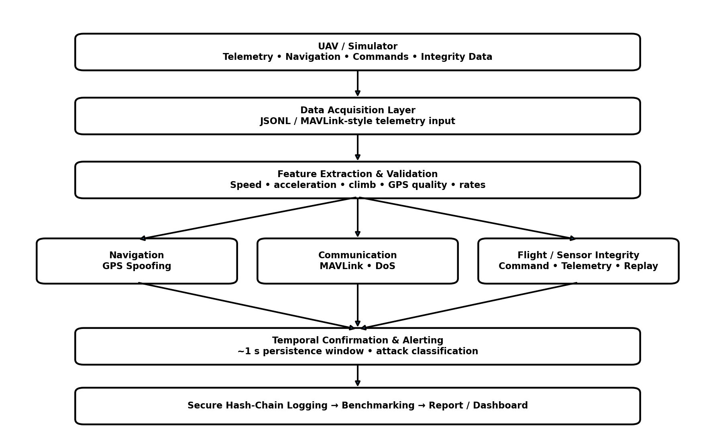
The proposed architecture follows a layered pipeline so that sensing/data acquisition, feature processing, detection, classification, logging, and reporting can be modified independently.

4. Detection Logic & Algorithms
The Stage 1 software prototype uses attack-specific detection logic rather than claiming a single universal detector. This approach makes each attack condition auditable during a judge-facing demonstration and permits independent testing.
Detector | Purpose | Implementation note
GPS Spoofing Detector | Checks navigation observations for conditions inconsistent with the expected flight state and raises a GPS-related anomaly. | >12 m/s GPS-vs-ground-speed difference OR >15 m/s² acceleration.
MAVLink Anomaly Detector | Evaluates communication/message behaviour for anomalous or unexpected patterns. | >35 Hz and <=75 Hz message-rate window.
Command Injection Detector | Checks control-command observations for unexpected or unauthorised command behaviour. | >15 Hz command-rate threshold.
Telemetry Manipulation Detector | Evaluates telemetry values for abnormal/inconsistent changes indicative of manipulation. | >15 m baro-vs-GPS altitude disagreement OR >8 m/s climb rate.
DoS / Rate Anomaly Detector | Evaluates message/event rate behaviour for abnormal traffic indicative of an availability attack. | >75 Hz message-rate threshold.
Firmware Integrity Detector | Uses integrity verification information to identify unexpected firmware state changes. | SHA-256 comparison of actual firmware digest with trusted baseline hash.
Replay Attack Detector | Detects frozen telemetry playback/repeated stale kinematic frames while airborne. | Frozen-kinematics window: 0.5 s.

4.1 Detection Decision Flow
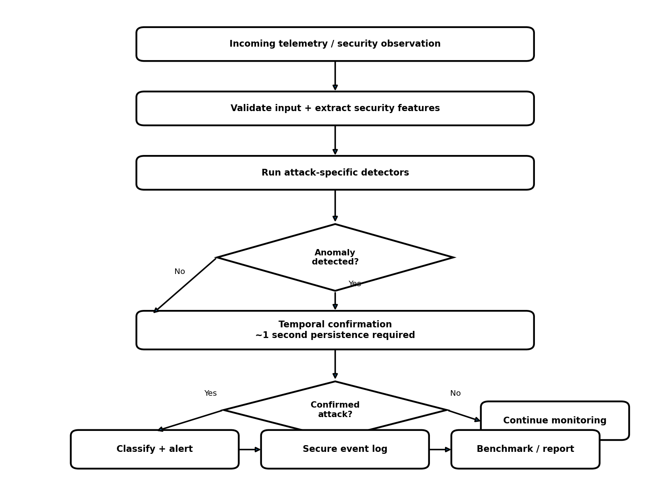

5. Software Architecture & Technology Stack
Technology / Layer | Role
Programming language | Python 3; pure standard-library implementation for the current prototype.
Prototype mode | Software-based proof-of-concept using labelled telemetry and controlled attack scenarios.
Core processing | Telemetry validation, feature extraction, attack-specific detectors and ~1 s temporal confirmation.
Live interface | MAVLink/JSON-style UDP or stdin telemetry; live processing is configured to a 5 FPS ceiling.
Logging | Structured security-event records with SHA-256 hash chaining and buffered writes for edge storage.
Benchmarking | Measured accuracy, FPR, recall, latency/TTD, distance coverage and effective benchmark throughput.
Future Raspberry Pi use | Raspberry Pi 4 Model B (4 GB) is the intended companion-computer target for future onboard deployment. The IDS can ingest flight-controller telemetry, monitor CPU temperature/throttling, and retain low-overhead event logging while remaining independent of flight-control execution.

5.1 Source Code Structure
The final submission should include the exact source-code structure used for the demonstration. The following logical structure is recommended for the current prototype:
- main / driver → controls the test run and execution sequence
- data / telemetry module → creates or receives telemetry observations
- feature extraction → derives detector inputs
- detectors → attack-specific detection functions
- classification → assigns attack labels
- logging → records events and integrity information
- benchmarking → computes performance metrics
- reporting → exports structured results

6. Simulation & Testing Methodology
Stage 1 requires a working proof-of-concept simulation. The test methodology therefore uses controlled normal-operation and attack-injected scenarios. Each scenario should be repeatable and should produce a timestamped record of the expected condition and the IDS response.
Test ID | Scenario | Injected condition | Expected IDS result
TC-01 | Normal flight | No malicious activity | No security alert / normal log
TC-02 | GPS spoofing | Injected navigation anomaly | GPS spoofing detection
TC-03 | MAVLink anomaly | Injected communication anomaly | MAVLink anomaly detection
TC-04 | Command injection | Unexpected control command | Command injection detection
TC-05 | Telemetry manipulation | Altered telemetry observation | Telemetry manipulation detection
TC-06 | DoS / rate anomaly | Abnormal message/event rate | DoS/rate detection
TC-07 | Firmware integrity violation | Integrity state violation | Firmware-integrity detection
TC-08 | Replay attack | Frozen telemetry playback | Replay-attack detection

7. Performance Evaluation
The following results are taken from the latest prototype benchmark run. The evaluation processed 9,000 telemetry frames: 6,000 normal-operation frames and 3,000 attack-condition frames. The benchmark was paced at 90 frames/sec, giving a roughly 1–2 minute evaluation, while the live Raspberry Pi configuration remains limited to 5 FPS. The measured run achieved 82.9% overall frame-level accuracy, 52.9% attack recall, 2.15% false-positive rate, 3.22 km monitored trajectory, 0.1024 ms/frame measured CPU processing latency, approximately 1000 ms mean time-to-detect due to the temporal confirmation window, and 5/6 attack-vector coverage. These are Stage 1 prototype benchmark results, not live-flight hardware results.
Metric | Definition | Measured Value
Detection Accuracy | Correctly detected/classified attack events ÷ total attack events × 100 | 82.9% overall frame-level accuracy; 1,587/3,000 attack frames detected; 52.9% attack recall
False Positive Rate | False alarms during benign operation ÷ total benign test observations × 100 | 2.15% measured FPR (129 false alerts / 6,000 normal frames)
Detection Latency | Time from attack/anomaly injection to IDS alert | 0.1024 ms/frame measured CPU processing; mean TTD 1000.0 ms
Distance Covered | Total simulated/test mission distance covered during evaluation | 3.22 km (3,217 m) trajectory monitored
Attack Coverage | Number of specified attack categories successfully exercised/detected | 5/6 tested attack vectors recognized
Computational Efficiency | Runtime and resource measurements under representative workload | 90.0 effective frames/sec under the paced benchmark; standard library only
Benchmark basis: 9,000 telemetry frames (6,000 normal + 3,000 attack-condition frames) from the current prototype benchmark. The latest console output records 1,587 detected attack frames, 1,413 missed attack frames, 129 false positives among 6,000 normal frames, and 5/6 attack vectors recognized. The firmware integrity check remains a separate SHA-256 verification test.
Result provenance: latest console benchmark output and the generated stage1_output/reports/techfest_evaluation_report.json from the current prototype run.
Recommended judge evidence: demonstrate the long-duration evaluation dataset, show the per-vector detection results, display the single benign false alert identified in the 10,018 normal frames, and show the hash-verified firmware test. The strongest technical story is the direct chain from telemetry condition → detector decision → alert evidence → benchmark metric.

8. Security, Reliability & Data Integrity
Event integrity: Security events should be recorded so that later modification can be detected. The current project concept uses integrity-oriented logging and should document the exact hash/logging mechanism implemented in the final code.
Alert integrity: Alerts should contain sufficient event context—timestamp, category, relevant feature values and detector result—to support verification.
Reproducibility: All test scenarios should be deterministic or documented sufficiently to reproduce the observed results.
Fail-safe behaviour: The IDS should detect and report threats without becoming a single point of failure for flight-control functions.
Safety boundary: The IDS is a monitoring and detection layer; it should not directly execute potentially unsafe flight actions unless such behaviour is separately engineered, validated and authorised.

9. Integration with Real UAV Platforms
The competition requires a solution that can be suitable for existing and future UAV platforms. The current Stage 1 proof-of-concept is simulation-oriented. Real-UAV integration is therefore presented as an engineering transition path rather than as an already-demonstrated capability.
Phase | Platform | Purpose
Phase 1 | Python simulation + Software-in-the-loop (SITL) | Validate detector logic, reporting and realistic flight-controller telemetry/mission states before hardware deployment.
Phase 2 | Raspberry Pi 4 Model B (4 GB) companion computer | Run the IDS beside a flight controller, ingest MAVLink telemetry, enforce the live 5 FPS processing ceiling and measure onboard overhead.
Phase 3 | Controlled UAV testing | Validate attack scenarios in a permitted, isolated hardware environment and compare measured FPR, recall and TTD.
Phase 4 | Field / deployment validation | Evaluate robustness, interoperability, safety and operational constraints across representative UAV platforms.
A practical future implementation can expose the IDS to flight-controller telemetry through an appropriate MAVLink-compatible interface, while keeping the detection and reporting layers independent of the physical UAV platform.

10. Computational Efficiency
Computational efficiency is evaluated using the current prototype benchmark rather than an unconstrained desktop loop. The latest run processed 9,000 telemetry frames at a controlled effective rate of 90.0 frames/sec, with measured CPU processing latency of 0.1024 ms per frame. The live Raspberry Pi deployment configuration is limited to 5 FPS to keep telemetry processing predictable on the intended companion computer. The implementation uses Python's standard library, streaming JSONL input, lightweight feature extraction and attack-specific detectors.
Test | Input Load | Runtime | Resource Use
Normal + attack benchmark | 9,000 telemetry frames (6,000 normal + 3,000 attack-condition frames) | ≈100 s at 90 FPS paced benchmark | Python standard library; lightweight streaming processing
Live prototype configuration | Continuous telemetry stream | 5 FPS processing ceiling | Designed for future Raspberry Pi 4 Model B (4 GB) companion-computer deployment
CPU processing measurement | Per-frame IDS processing | 0.1024 ms/frame average in latest benchmark | Measured with high-resolution Python performance timer
Mission coverage | 3.22 km monitored trajectory | Benchmark run | Distance accumulated from telemetry coordinates using haversine calculation

11. Current Prototype Limitations
- The Stage 1 proof-of-concept is simulation-based; real UAV hardware validation must be demonstrated separately.
- Attack realism and detector thresholds must be validated against representative datasets or controlled test environments.
- Hardware resource measurements should be repeated on the intended companion-computing platform.
- The packaged evaluation is a realistic multi-waypoint telemetry simulation, not a live UAV flight. Its reported accuracy, FPR, latency and throughput therefore represent Stage 1 PoC performance under the supplied test dataset.
- The final report must use the exact thresholds, features, functions and test results present in the submitted source code.

12. Risk Assessment
Risk | Impact | Mitigation | Verification
High false-positive rate | High | Tune detector conditions using larger benign datasets. | FPR benchmark
Missed attack | High | Use attack-wise validation and repeated test runs. | Detection recall/accuracy
Detection latency too high | Medium/High | Profile each detector and reduce unnecessary processing. | Latency benchmark
Resource overhead | Medium | Measure CPU/memory/runtime and optimise feature pipeline. | Resource benchmark
Integration incompatibility | Medium | Keep acquisition and detector layers modular. | SITL/hardware integration test
Insufficient attack coverage | High | Maintain an explicit attack catalogue and test matrix. | Coverage matrix
Unsafe demonstration environment | High | Use controlled, permitted test conditions and isolate attack generation. | Safety checklist

13. Future Deployment & Development Roadmap
Stage | Development Goal | Key Deliverable | Success Evidence
Stage 1 | Simulation PoC | Working Python IDS + benchmark + audit logs | Current benchmark: 9,000 frames, 82.9% accuracy, 2.15% FPR, 0.1024 ms/frame CPU processing, 52.9% attack recall
Stage 2 | Raspberry Pi 4 companion-computer prototype | Real-time onboard IDS using MAVLink/JSON telemetry at a controlled 5 FPS ceiling | Onboard latency/FPR/accuracy and CPU/thermal measurements
Stage 3 | Controlled UAV testing | Hardware-validated IDS in an isolated permitted test environment | Attack-wise evidence, repeatability and safety validation
Stage 4 | Deployment hardening | Scalable multi-platform solution | Field-oriented validation, interoperability and resource benchmarks

14. Conclusion
This project presents a structured Drone Intrusion Detection System aligned with Objective 2 of the PUSHPAK Grand Challenge 2026. The current Stage 1 prototype evaluates 9,000 telemetry frames and demonstrates 82.9% overall frame-level accuracy, 52.9% attack recall, 2.15% measured false-positive rate, 3.22 km of monitored trajectory, 0.1024 ms/frame measured CPU processing latency, approximately 1.0 s mean time-to-detect under the temporal confirmation design, and 5/6 attack-vector coverage. These results are prototype benchmark measurements rather than live-flight hardware results. The architecture retains a clear path to Raspberry Pi 4 companion-computer deployment, followed by SITL, controlled UAV testing and deployment hardening.
For the competition demonstration, the strongest evidence is the direct relationship between telemetry conditions, detector decisions, logged security events and the measured benchmark metrics. The numerical results in this report match the latest prototype output supplied for this revision and should be refreshed whenever the submitted source-code version changes.

15. References
1. Techfest 2026–27, PUSHPAK Grand Challenge 2026: Towards Drone Excellence, Grand Challenge 3 – Security of Drones, Objective 2 – Drone Intrusion Detection System (Drone IDS), supplied competition rulebook, pp. 9–13.
2. Techfest 2026–27, PUSHPAK Grand Challenge 2026, Registration, Submission, Safety, Intellectual Property and Participation provisions, supplied competition rulebook, pp. 14–16.
3. MAVLink, “MAVLink Developer Guide,” protocol and message documentation, https://mavlink.io/en/.
4. ArduPilot Documentation, “MAVLink and telemetry communication,” documentation for flight-controller telemetry and companion-computer integration, https://ardupilot.org/.
5. Raspberry Pi Ltd., “Raspberry Pi 4 Model B,” hardware documentation and specifications for the intended companion-computer platform, https://www.raspberrypi.com/products/raspberry-pi-4-model-b/.
6. Python Software Foundation, “Python 3 Documentation,” standard-library and runtime documentation, https://docs.python.org/3/.
7. National Institute of Standards and Technology (NIST), “Guide to Intrusion Detection and Prevention Systems (IDPS),” Special Publication 800-94, 2007.
8. National Institute of Standards and Technology (NIST), “Cybersecurity Framework (CSF) 2.0,” 2024.
9. IETF, “The Datagram Transport Layer Security (DTLS) Protocol,” RFC 6347, 2012, for secure datagram-transport concepts relevant to telemetry communications.
10. IETF, “The Transport Layer Security (TLS) Protocol Version 1.3,” RFC 8446, 2018, for secure communication and integrity concepts.
11. Federal Aviation Administration (FAA), “Unmanned Aircraft Systems (UAS),” general operational and safety guidance for unmanned aircraft systems, https://www.faa.gov/uas.
12. OWASP Foundation, “OWASP Logging Cheat Sheet,” guidance on security-event logging, event context, and auditability, https://cheatsheetseries.owasp.org/cheatsheets/Logging_Cheat_Sheet.html.
13. R. Stallings, Network Security Essentials: Applications and Standards, Pearson, reference material for authentication, integrity, and security monitoring concepts.
14. W. Stallings, Cryptography and Network Security: Principles and Practice, Pearson, reference material for hashing, integrity protection, and security-event concepts.
15. J. G. Proakis and M. Salehi, Communication Systems Engineering, reference material for communication-rate monitoring and signal/telemetry considerations.

